Student Name: Yinsheng Dong

Student Number: 11148648

NSID: yid164

CMPT 412 Assignment 2

1. Plot a network graph using the data.

I imported the EDGES.xlsx and NODES.xlsx to Gephi. Then I initially get the network graph, and I colored the nodes to red and the edges to green, so the graph like below:



1. Compute the graph metrics degree, betweenness and closeness. Identify those on the graph with the highest of each metric. For example, show on the network graph who has the highest degree, betweenness and closeness
2. Highest Degree:

First, we need to run the “average degree” which is in the Statistic side bar. Then I ranked these nodes by degree from light (lower degree) to dark (higher degree) then I got the picture like this:

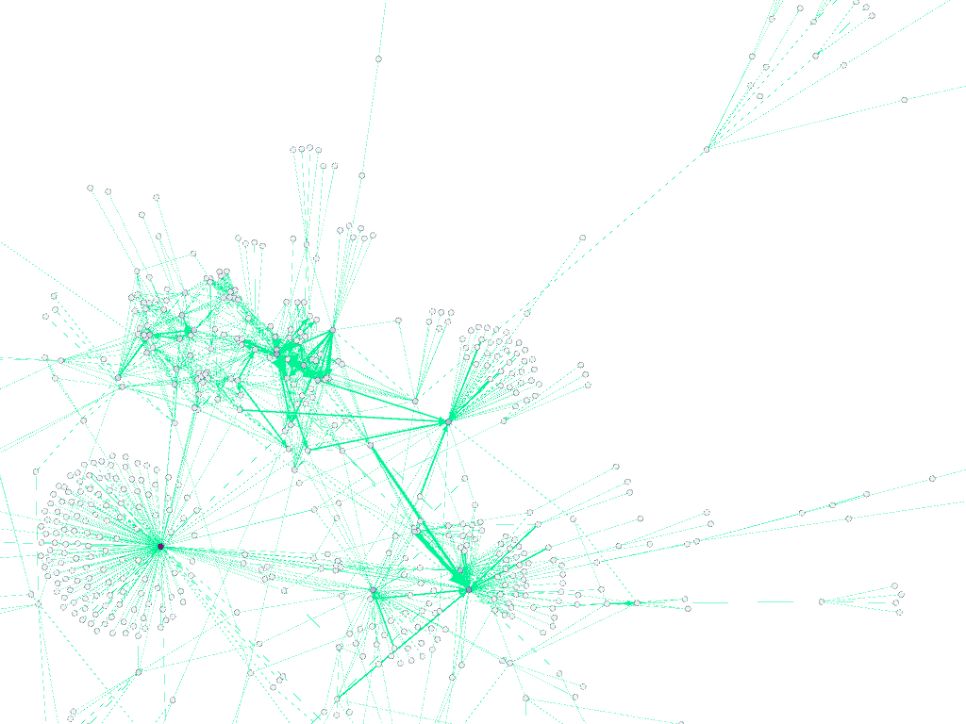

Then, I clicked the darkest point to find it in Data Laboratory.

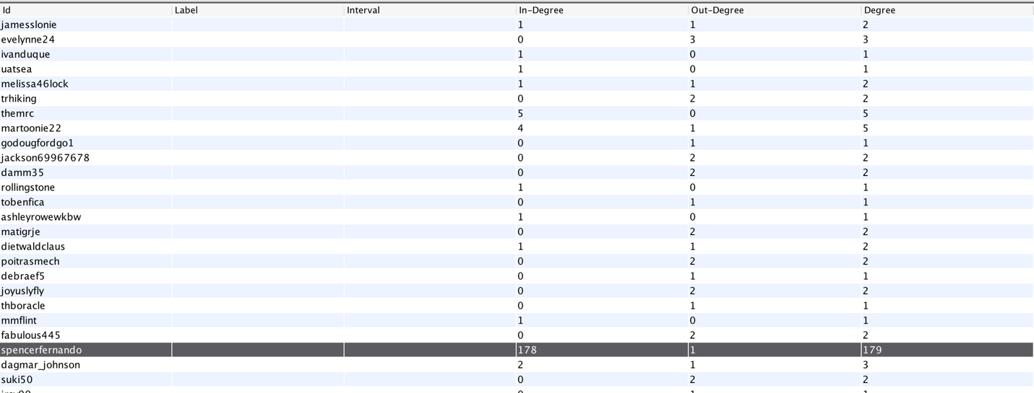

Then, I found “spencerfernando” has the highest degree which is 179

1. Betweenness:

After I clicked the “network diameter”, then I ranked the betweenness from light (low) to dark (high)

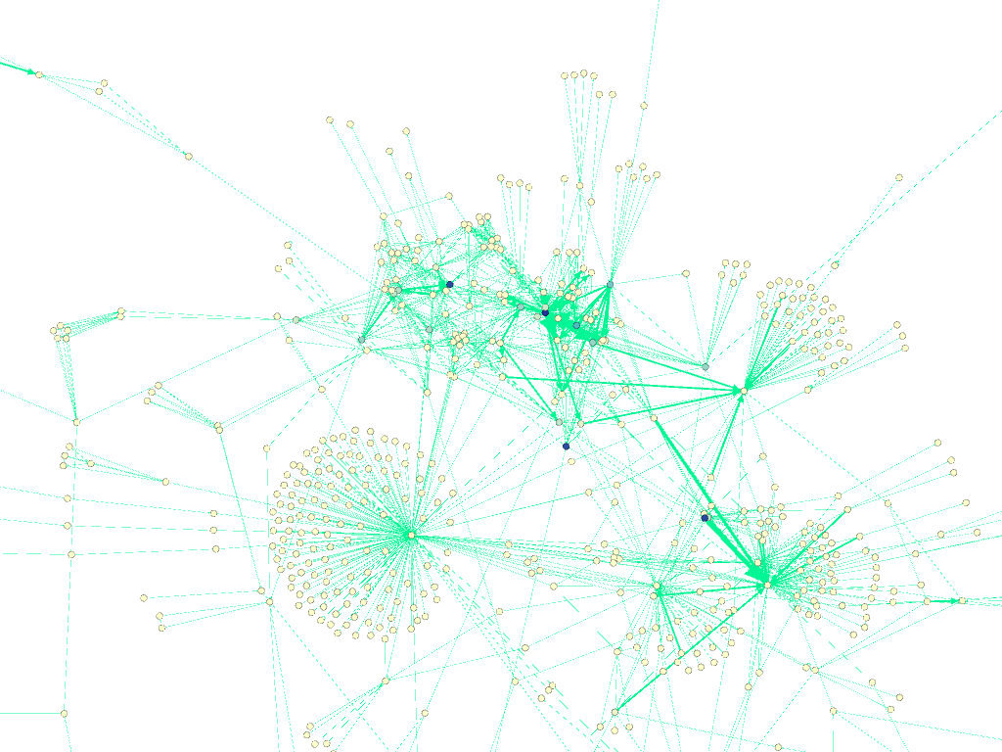

Then, I ranged the betweenness to the highest one which is 1617.15:

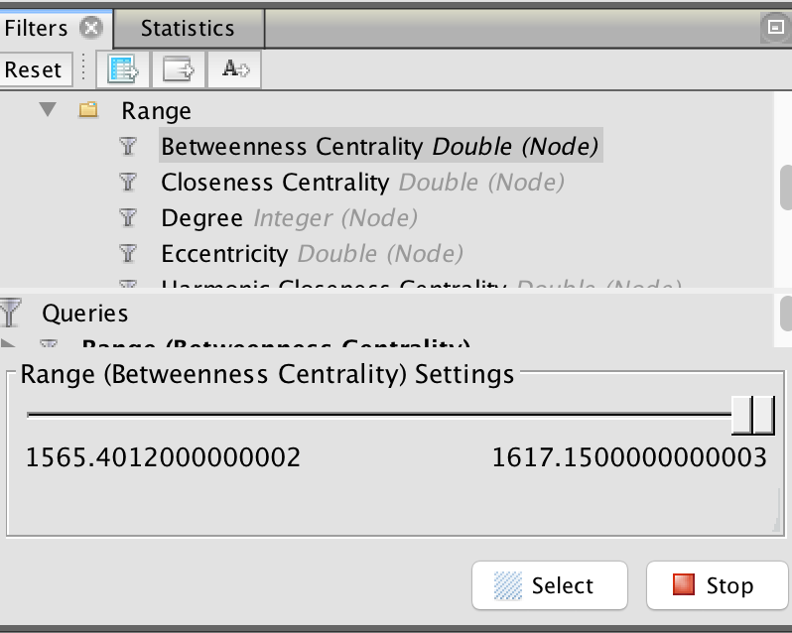

Then, I found it in Data Laboratory:



Which is “vaholdo” who has the highest betweenness Centrality.

1. Closeness

I used the same way like previous steps, and the nodes are also from light(low closeness) to dark (high closeness):

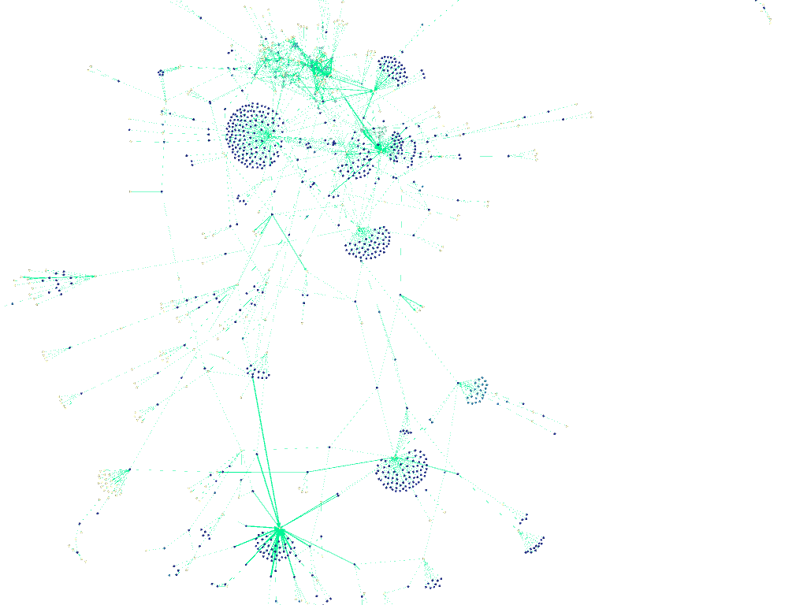

Then I found there are many points have high closeness, so I got data from the Data Laboratory.

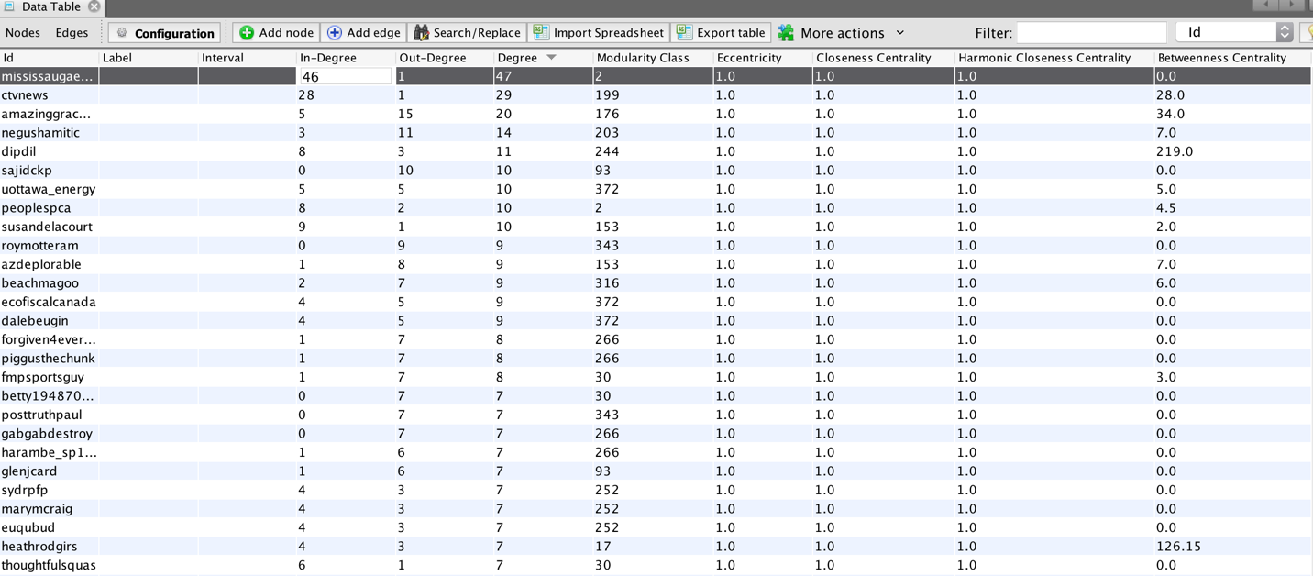

And there are 1089 nodes have the highest closeness which is 1.0. We might choose the “mississaugaeast” as the point we desire because in all the points which have the highest closeness, it has the highest degree.

1. Identify three people in the network who you think you should employ as your social media political campaigner and justify why.

I will choose three people defined in question 2 who are “spencerfernando”, “vaholdo”, and “mississaugaeast”.

“spencerfernando”: This person has the highest degree, especially this person has the highest indegree which means most people are following his Twitter, so if we hire this person, more people can know what we want to say.

“vaholdo”: This person has the highest betweenness than others, which means people could know each other through out by this person. If we hire “vaholdo”, the message can be published indirectly by him, and more people would know what we want to say.

“mississaugaeast”: This person is the one of people who are having the highest closeness. But I choose this person because “mississaugaeast” has the highest degrees in those people who are having the highest closeness. So “mississaugaeast” will be able to publish what we want to say faster.

1. Of these three, look them up on Twitter and carry out a sentiment analysis of their last 10 tweets each. What can you say about these three people in terms of the sentiments they use in their tweets. (Do they use positive /negative sentiments, are they in favor/against a political party etc.)
2. “spencerfernando”: here are the screenshots of his tweets.

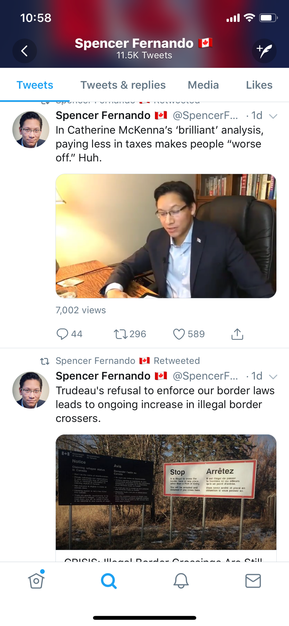

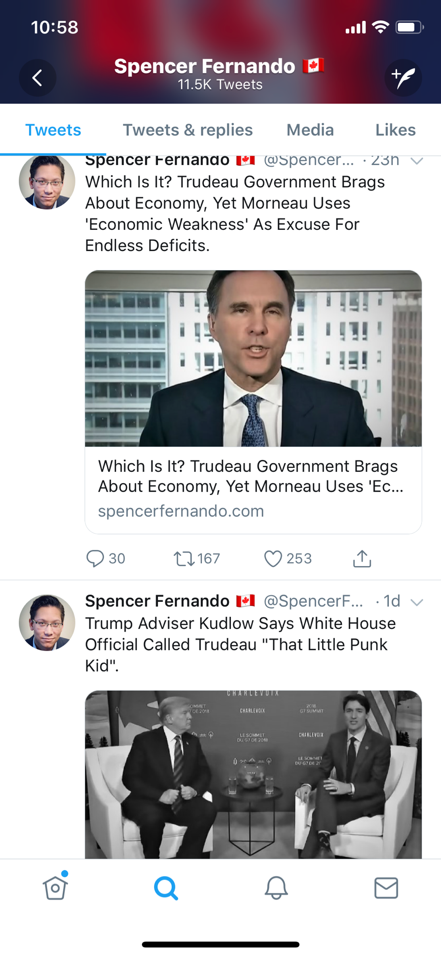

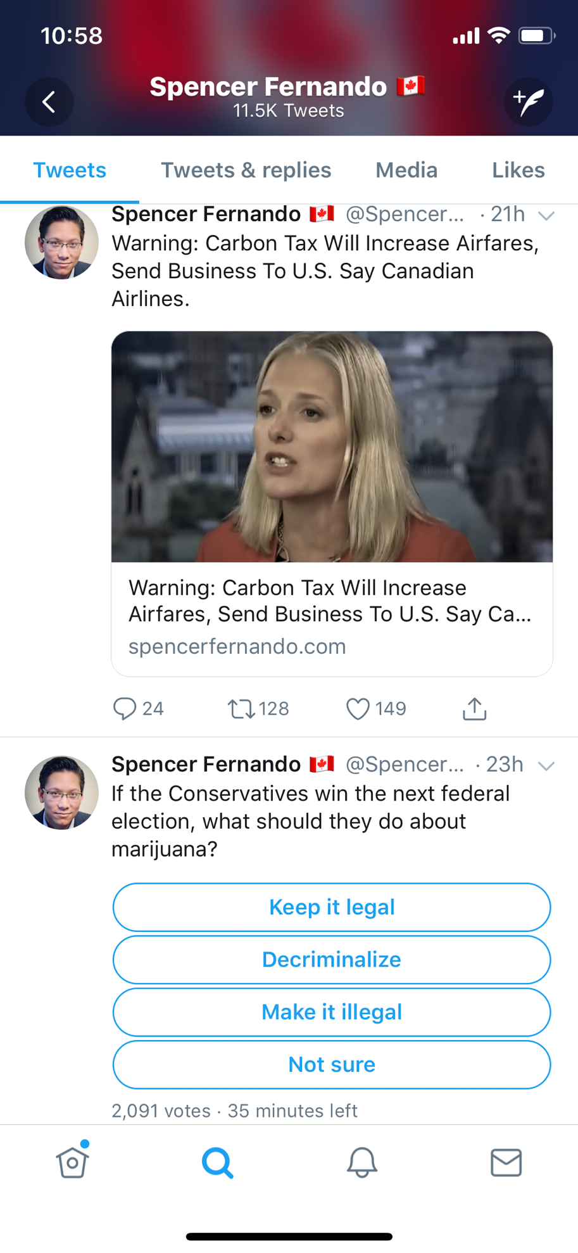

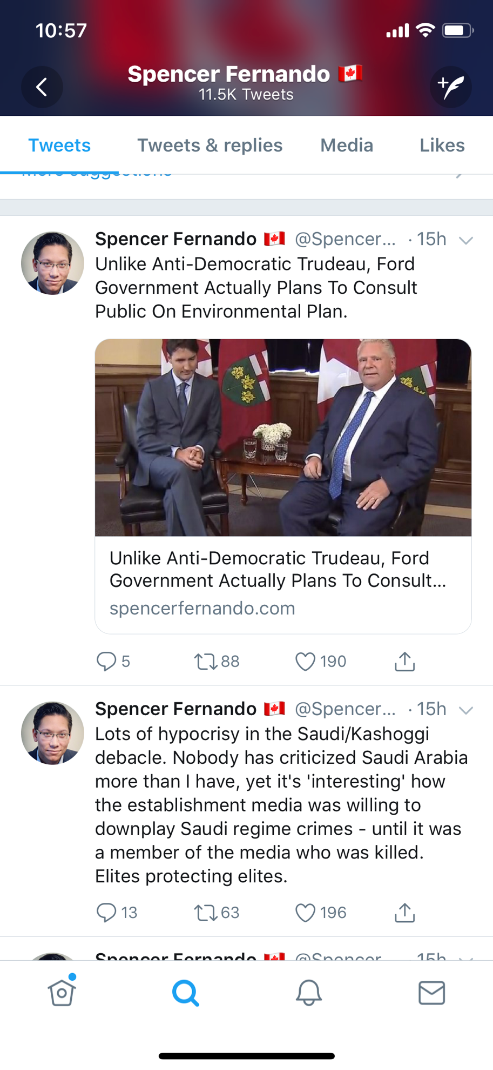



According these tweets from his Tweeter, he against Trudeau government obviously. Also, he expressed some negative words for his against, and tot satisfied Canadian government right now.

1. “vaholdo”:

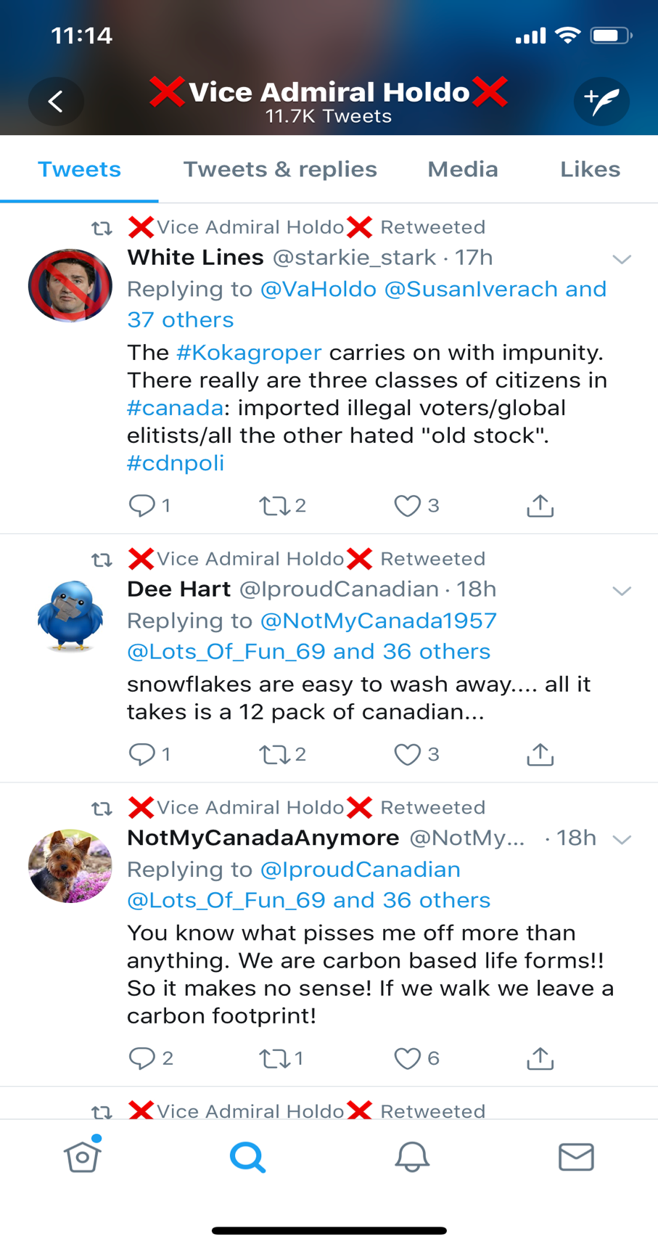

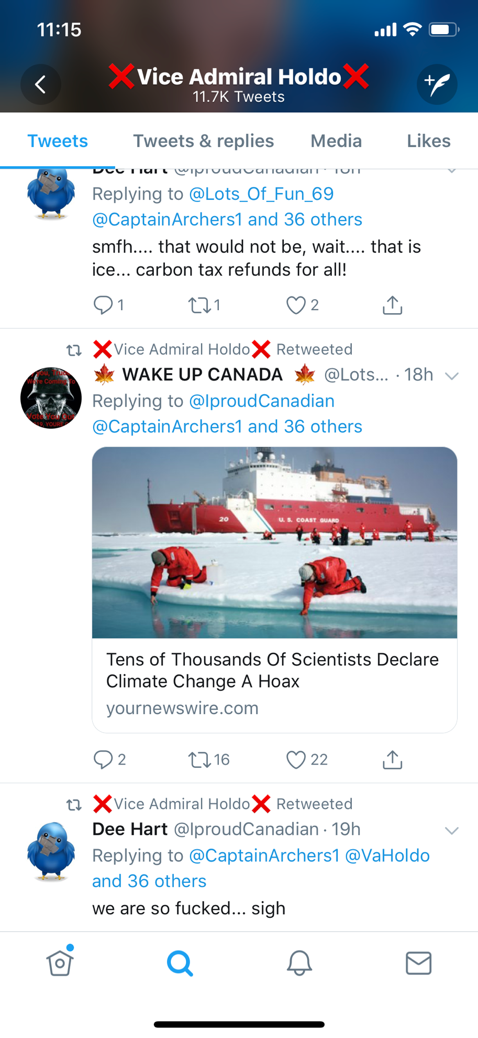

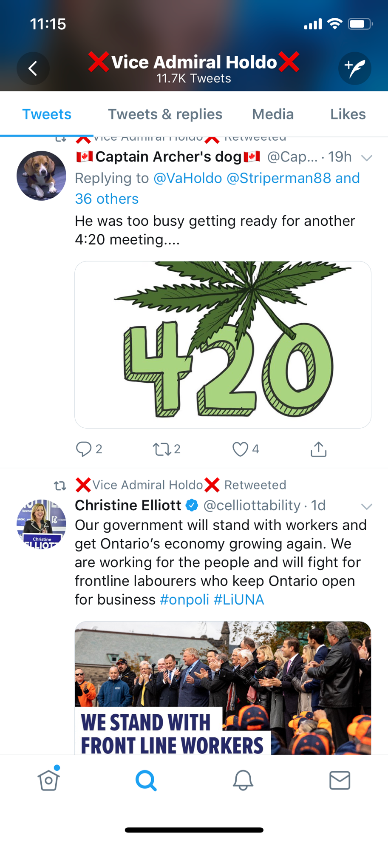

Obviously, “vaholdo” ‘s tweets also against Trudeau government as well according to vaholdo’s tweets and retweets. However, this person also tweeted some positive sentiments.

1. “mississaugaeast”:

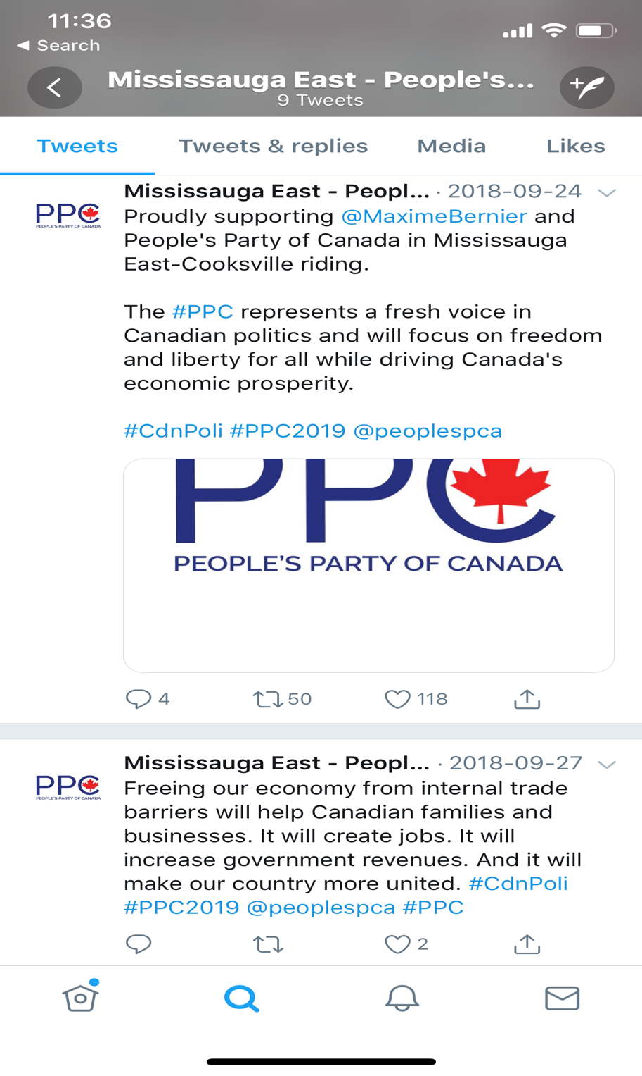

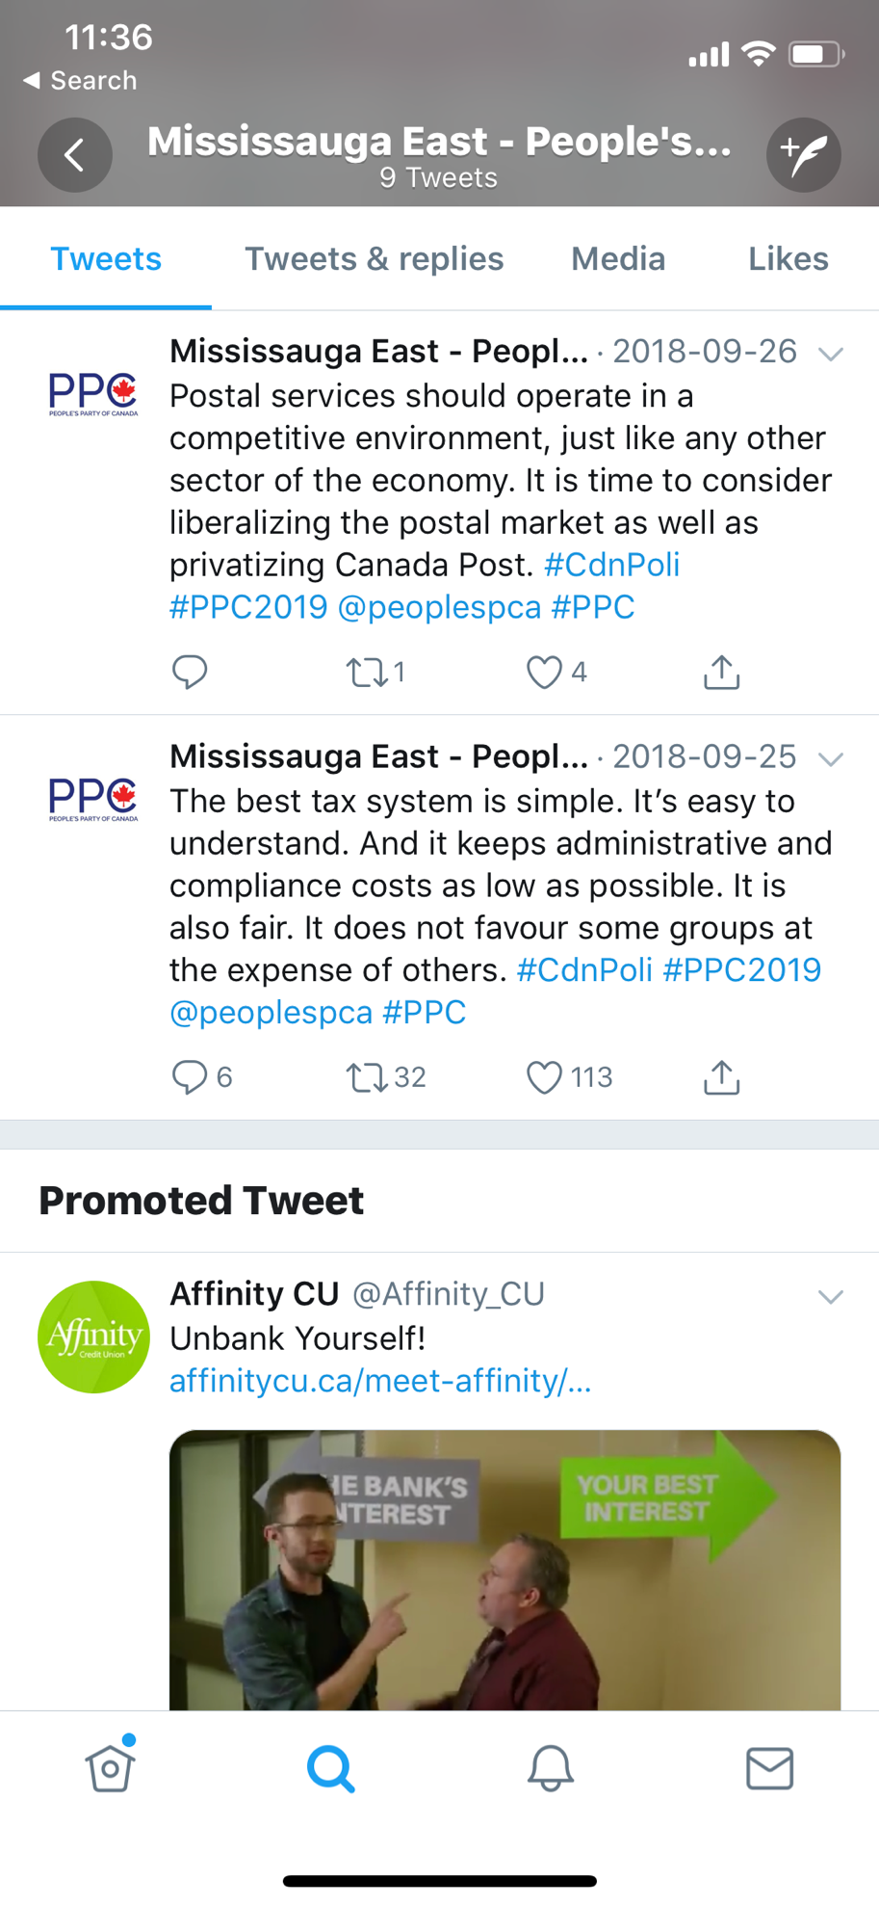

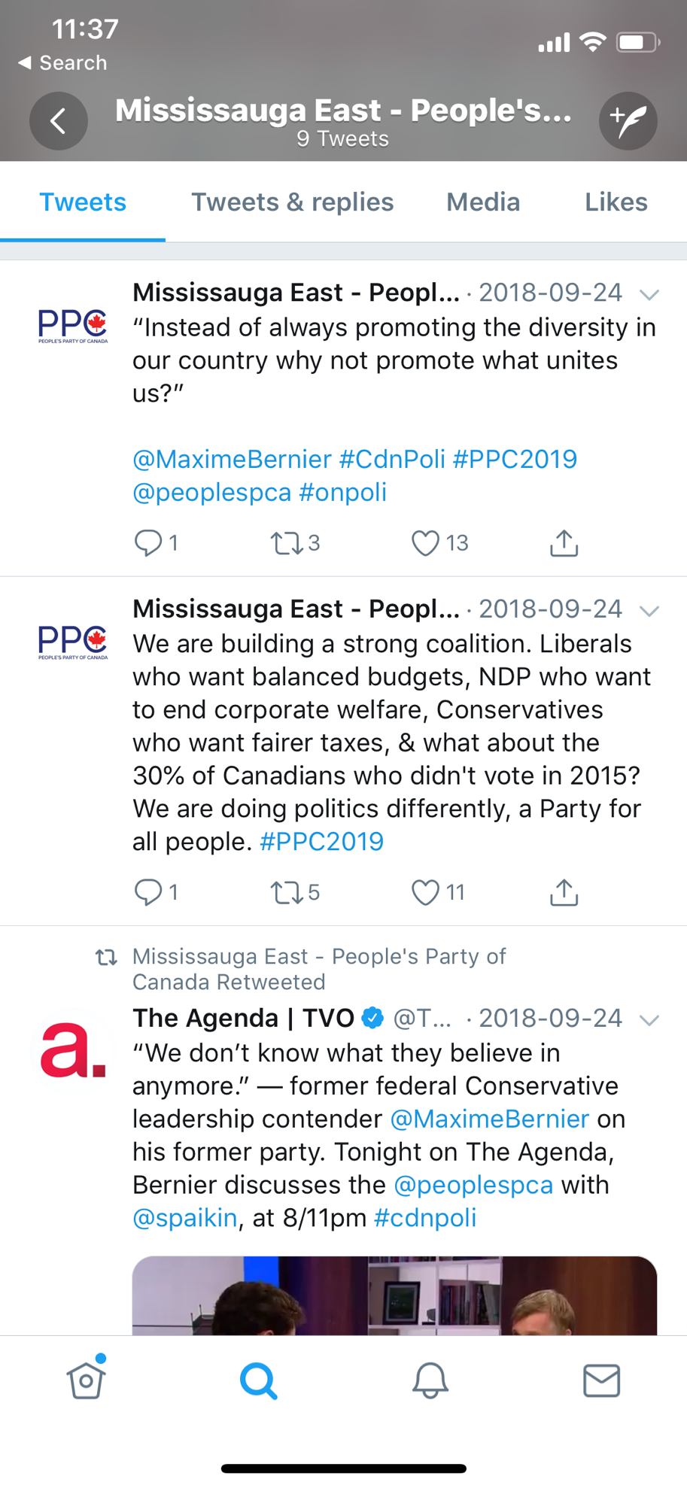

Since “mississaugaeast” only has 9 tweets, so I just analysed 9. “mississaugaeast” is an organization which named “Mississauga East – People’s Party of Canada”. This tweeter introduced themselves and give some positive advises for government and people. Also, the person tweeted some messages against to the current tax system and some political. Overall, this person is impartial.

1. Plot a word cloud for each person and identify similarities and differences between the three people.
   1. “spencerfernando”:



* 1. “vaholdo”:



* 1. “mississaugaeast”:

